**Digital Image Processing Laboratory**

Experiment Report

Experiment Title Fourier Transform and Frequency

Domain Filtering

Student’s Name 蒋云翔

Student’s ID 2022102330

Class CST

Date handed in 2024/11/25

International school, Jinan University

**A. Objectives**

1. To know how to use Discrete Fourier Transform **(DFT)**.
2. To know how to process images in frequency domain by high-pass filter or low-pass filter in MATLAB.

**B. Technique**

In this project, my ***selfie*** will be used.

(1) Perform ***Fourier transform***, and ***inverse Fourier transform*** to images.

(2) Apply a ***low-pass filter*** to the image.

(3) Add a ***high-pass filter*** to the image.

**C. Experiment Content**

1. **Task1:** Read the image ***bag.png*** (or your **selfie**, if it is color photo, please convert it into gray) given in the folder，show it, perform Fourier transform on it, show the **magnitude** image and **phase angle** image in frequency domain. Then perform inverse Fourier transform, show image, compare with the original one to see if they are identity
2. **Step1:** Read the image and convert it to a grayscale image and display the original grayscale image.

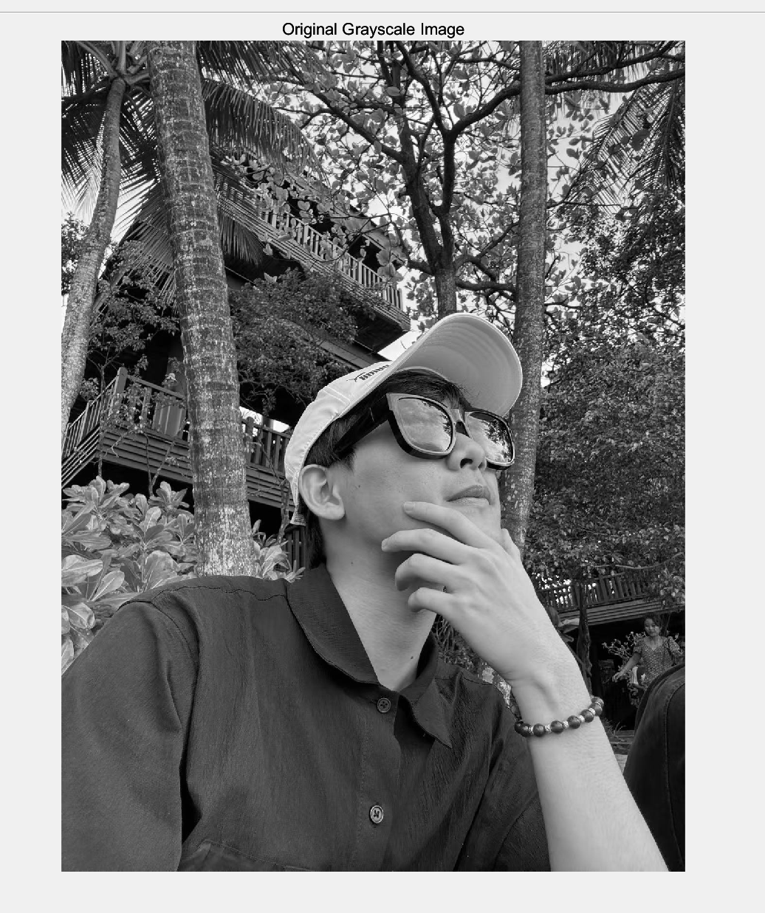

Figure 1: Display the original grayscale image

1. **Step2:** Fourier transform is performed on the image, and the amplitude image and phase Angle image in the frequency domain are displayed.

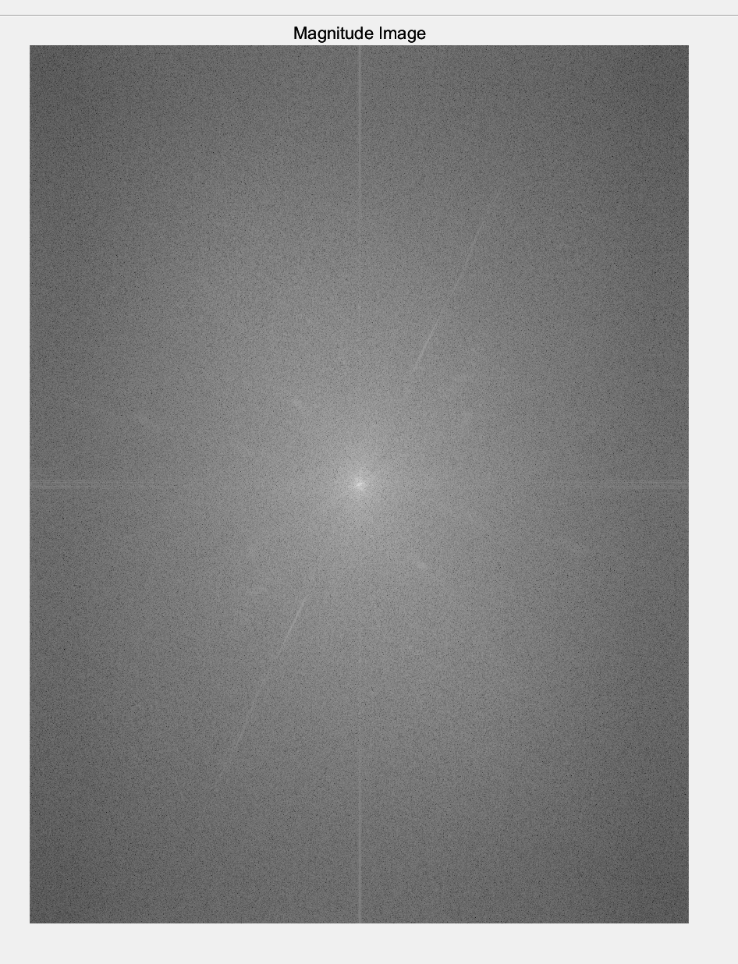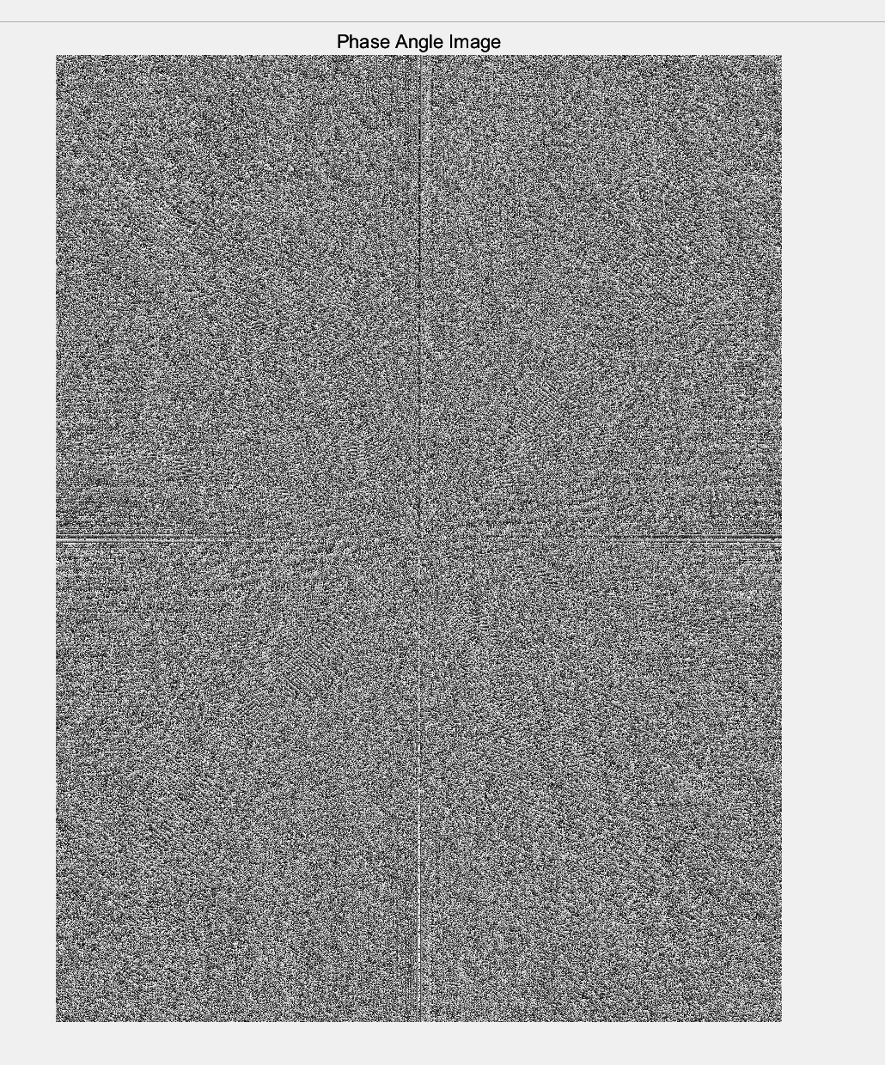

Figure2: amplitude image and phase Angle image in the frequency domain

The amplitude image shows the amplitude information in the frequency domain after the Fourier transform. Fourier transform transforms the spatial domain image into the frequency domain, showing the frequency component of the image. The central part of the image has **the highest brightness**, which indicates that the low-frequency components are concentrated in the center of the image. The low-frequency components represent the overall structure and main contours in the image. As it expands outward from the center, the image brightness gradually decreases, indicating that the high-frequency components are distributed in the periphery. High-frequency components represent details and edges in the image.

The phase Angle image shows the phase information in the frequency domain after Fourier transform. The phase Angle image shows the phase information for each frequency component. The image presents a random texture and noise-like distribution. Phase information is crucial in the reconstruction of the image, which determines the spatial position and arrangement of each part of the image.

1. **Step3:** Inverse Fourier transform is performed on the frequency domain image and the recovered image is displayed.

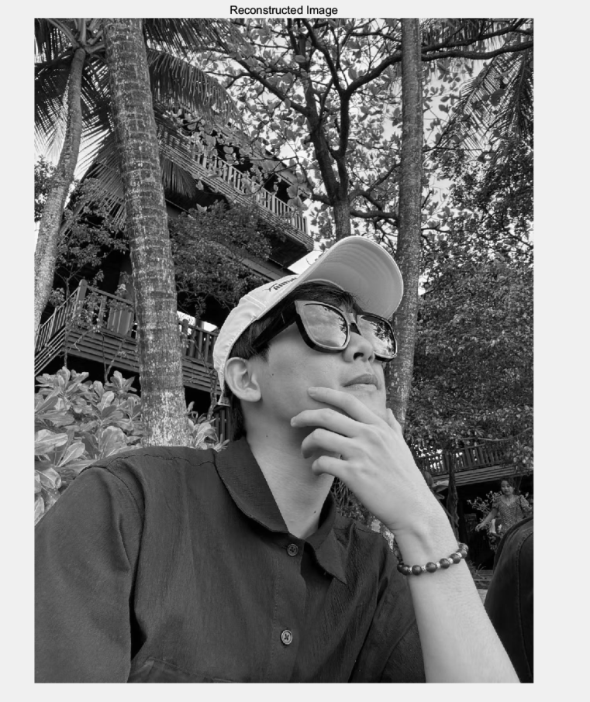

Figure 3: Recovered image (Inverse Fourier transform)

1. **Step4:** Compare the recovered image with the original image to see if they are the same.



Figure 4: Comparison between the original and the reconstructed one

Based on the visual inspection and the MSE calculation, you can conclude that the original and reconstructed images are **effectively the same**. Any minor differences might be due to numerical precision errors, but they should not be visually significant.

The following code implements the above functionality:

|  |
| --- |
| % Read the image and convert it to grayscale  img = imread("C:\License\selfie1.jpg"); % Replace with your image path  gray_img = rgb2gray(img);  figure, imshow(gray_img), title('Original Grayscale Image');  % Perform Fourier transform  F = fft2(double(gray_img));  F_shifted = fftshift(F);  magnitude = abs(F_shifted);  phase = angle(F_shifted);  % Display the magnitude image and phase angle image in the frequency domain  figure, imshow(log(1 + magnitude), []), title('Magnitude Image');  figure, imshow(phase, []), title('Phase Angle Image');  % Perform inverse Fourier transform  F_inv_shifted = ifftshift(F_shifted);  img_reconstructed = ifft2(F_inv_shifted);  img_reconstructed = abs(img_reconstructed);  figure, imshow(img_reconstructed, []), title('Reconstructed Image');  % Compare the reconstructed image with the original image  difference = immse(gray_img, img_reconstructed);  fprintf('Mean Squared Error (MSE): %f\n', difference); |

1. **Task2:** Apply several Low-pass filters on your **selfie** (as above, keep it as a gray image). The low-pass filters include ideal low-pass filter (ILPF), Butterworth low-pass filter (BLPF) and Gaussian low-pass filter (GLPF). Observe the differences between the original image and filtered image under different cut-off frequencies when the same type of LPF has been performed.
2. Read the image, convert it into grey.
3. Fourier transform the image and shift it.
4. Apply several low-pass filters on image (ILPF, BLPF and GLPF) under different cut-off frequencies.
5. Display the comparison among the original image and the modified images

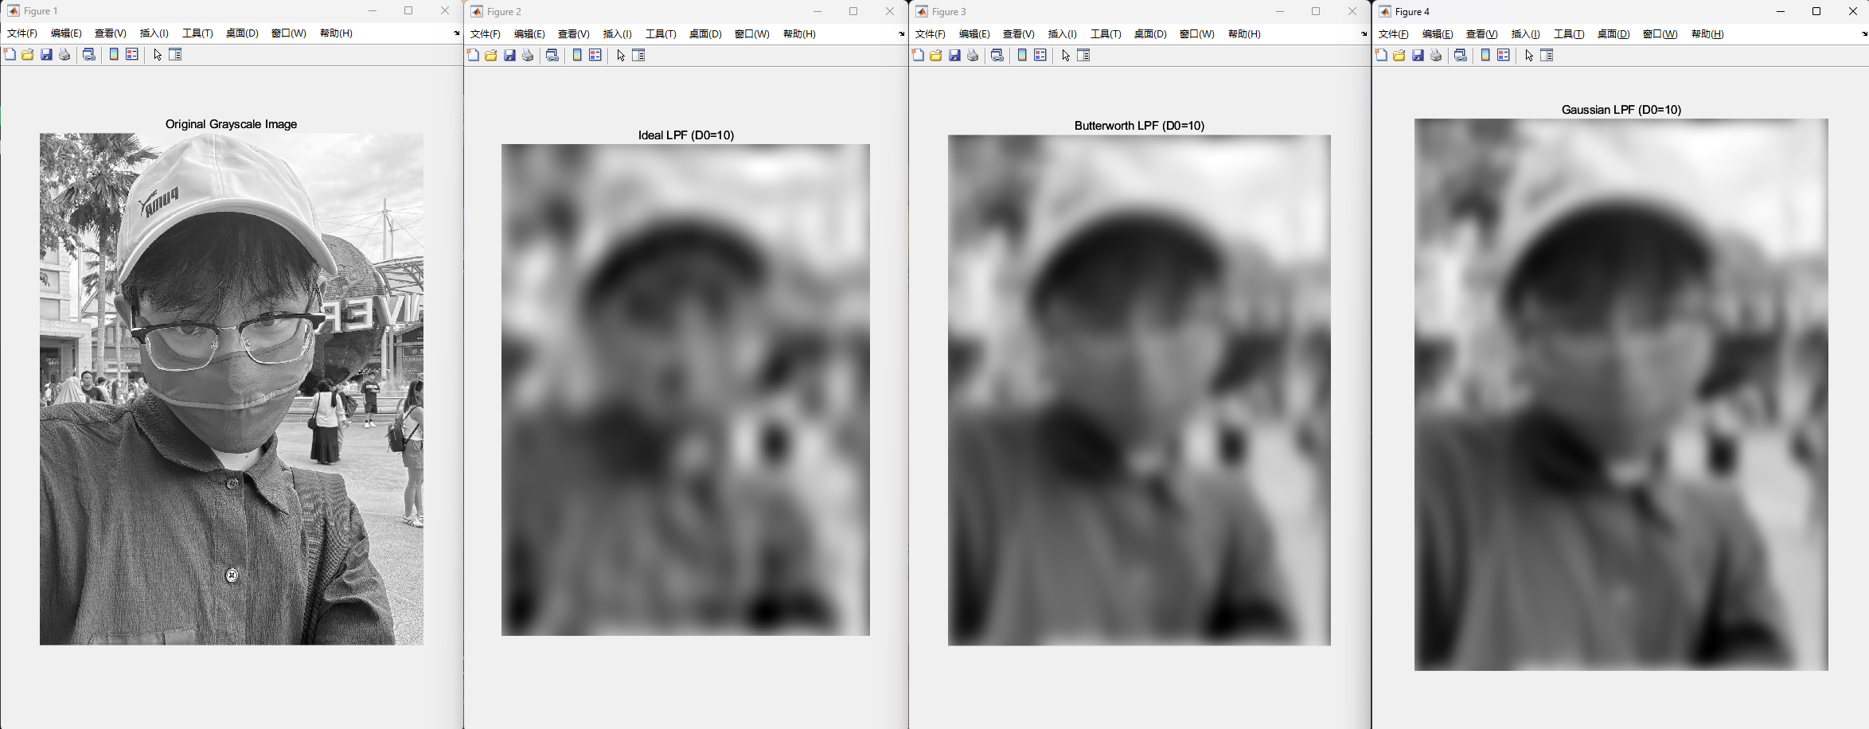

Figure 5: Comparison when cut-off frequency = 10

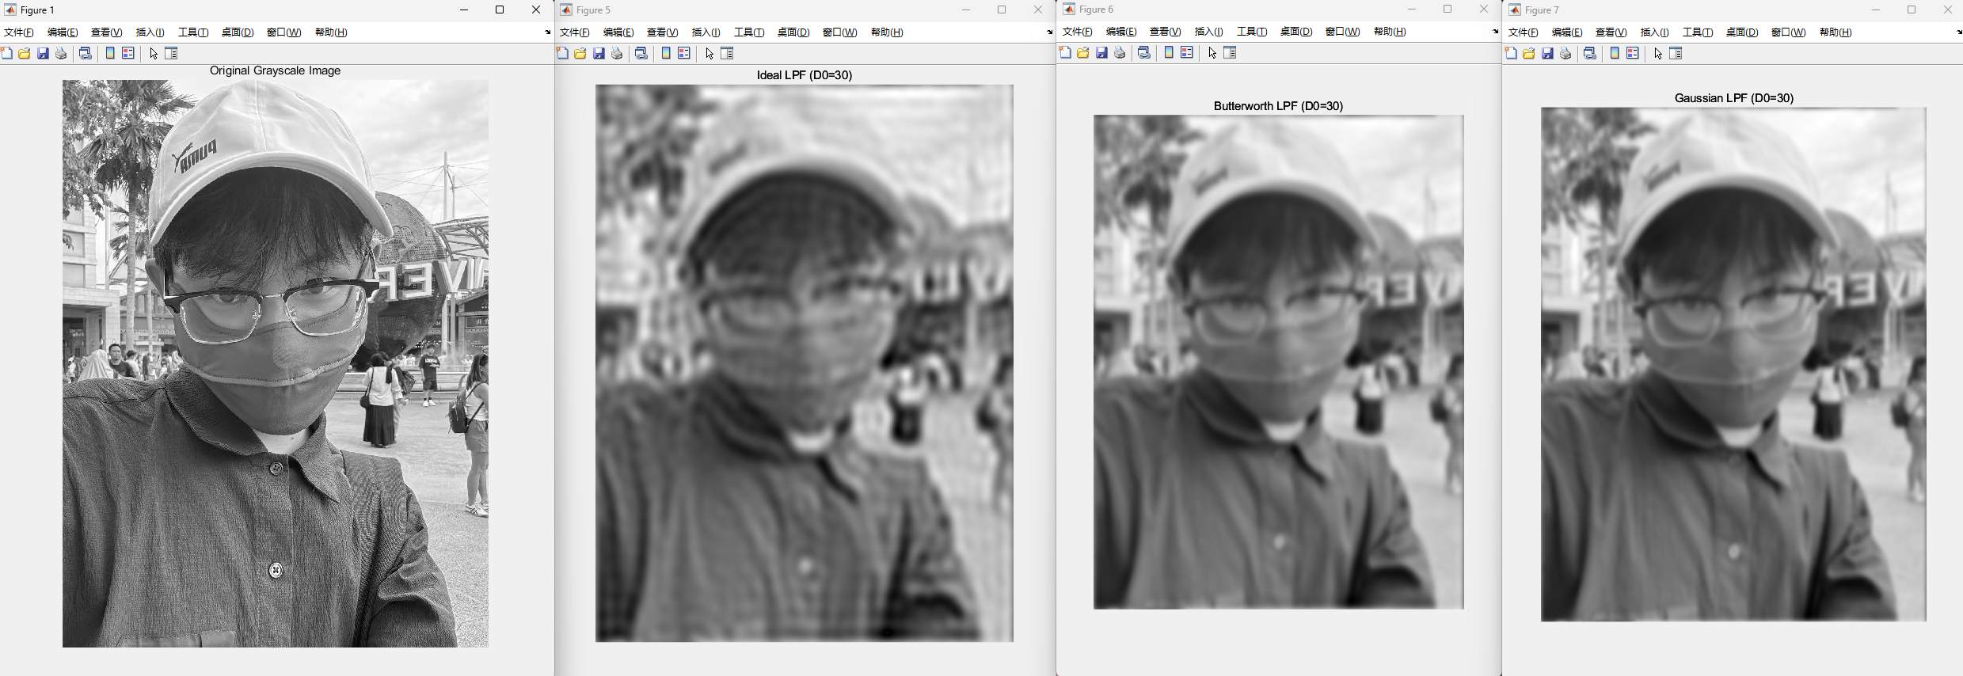

Figure 6: Comparison when cut-off frequency = 30

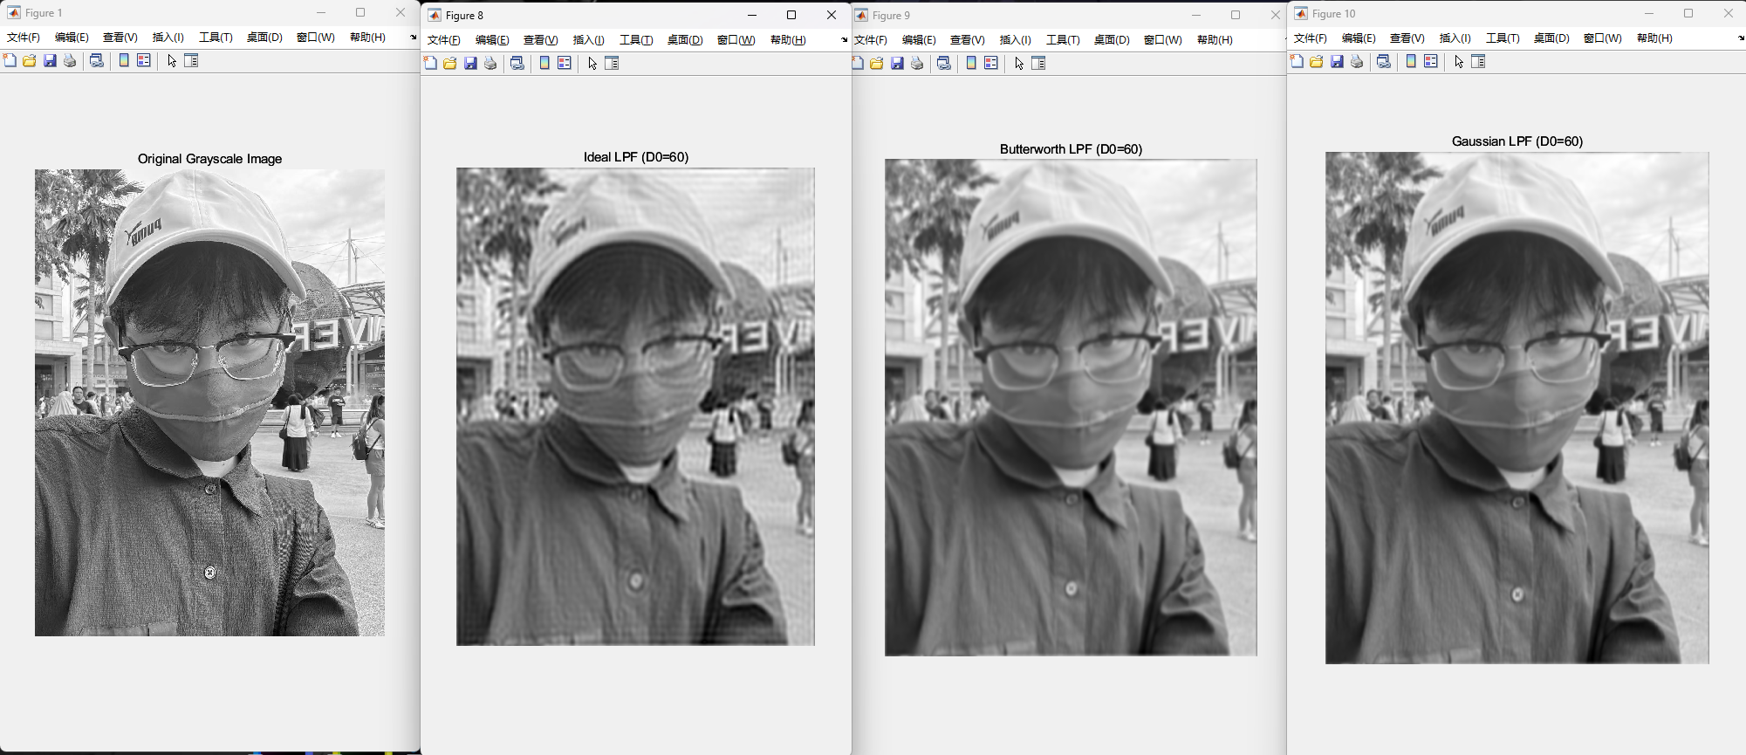

Figure 7: Comparison when cut-off frequency = 60

The above images represent filtered results using Butterworth (BLPF), Gaussian (GLPF), and Ideal (ILPF) low-pass filters at cut-off frequencies of 10, 30, and 60.

The filters with a cut-off frequency of 10 show a very blurred image where only the most general shape of the subject can be discerned. When the filters with a cut-off frequency of 30, the blurring is reduced, and more details begin to emerge, though the image is still quite soft. At a cut-off frequency of 60, the image has much more detail, and the blurring effect is much less pronounced, resulting in a clearer image that resembles the original more closely

* **Ideal LPF**: The image exhibits a sharp cutoff at the specified frequency, leading to the suppression of high-frequency details and the retention of the overall structure. Edges and fine details become increasingly blurred as the cut-off frequency decreases.
* **Butterworth LPF**: This filter provides a smoother transition compared to the Ideal LPF. The higher the order (n), the sharper the transition. It effectively reduces high-frequency noise and creates a smoother image.
* **Gaussian LPF**: This filter offers the smoothest transition among the three, resulting in a gradual blurring effect that reduces high-frequency noise without introducing artifacts.

The following code implements the above functionality:

|  |
| --- |
| % Read the grayscale image  img = imread("C:\License\selfie2.jpg"); % Replace with your image path  gray_img = rgb2gray(img);  figure, imshow(gray_img), title('Original Grayscale Image');  % Perform Fourier Transform  F = fft2(double(gray_img));  F_shifted = fftshift(F);  % Apply Low-pass filters with different cut-off frequencies  D0_values = [10, 30, 60]; % Different cut-off frequencies  for D0 = D0_values  H_ideal = idealLPF(D0, size(gray_img, 1), size(gray_img, 2));  H_butter = butterworthLPF(D0, 2, size(gray_img, 1), size(gray_img, 2)); % n=2  H_gaussian = gaussianLPF(D0, size(gray_img, 1), size(gray_img, 2));  % Filter the image  F_ideal = H_ideal .* F_shifted;  F_butter = H_butter .* F_shifted;  F_gaussian = H_gaussian .* F_shifted;  img_ideal = ifft2(ifftshift(F_ideal));  img_ideal = abs(img_ideal);  img_butter = ifft2(ifftshift(F_butter));  img_butter = abs(img_butter);  img_gaussian = ifft2(ifftshift(F_gaussian));  img_gaussian = abs(img_gaussian);  % Display filtered images  figure, imshow(img_ideal, []), title(['Ideal LPF (D0=' num2str(D0) ')']);  figure, imshow(img_butter, []), title(['Butterworth LPF (D0=' num2str(D0) ')']);  figure, imshow(img_gaussian, []), title(['Gaussian LPF (D0=' num2str(D0) ')']);  end  % Define Low-pass filter functions  function H = idealLPF(D0, M, N)  [U, V] = meshgrid(1:N, 1:M);  D = sqrt((U - N/2).^2 + (V - M/2).^2);  H = double(D <= D0);  end  function H = butterworthLPF(D0, n, M, N)  [U, V] = meshgrid(1:N, 1:M);  D = sqrt((U - N/2).^2 + (V - M/2).^2);  H = 1 ./ (1 + (D ./ D0).^(2*n));  end  function H = gaussianLPF(D0, M, N)  [U, V] = meshgrid(1:N, 1:M);  D = sqrt((U - N/2).^2 + (V - M/2).^2);  H = exp(-(D.^2) / (2 * D0^2));  end |

1. **Task3:** Apply ideal high-pass filter (IHPF), Butterworth high-pass filter (BHPF) and Gaussian high-pass filter (GHPF) on your **selfie**, respectively. Observe the differences between the original image and filtered image under different cut-off frequencies when the same type of HPF has been performed.
2. Read the image, convert it into grey.
3. Fourier transform the image and shift it.
4. Apply several high-pass filters on image (IHPF, BHPF and GHPF) under different cut-off frequencies.
5. Display the comparison among the original image and the modified images

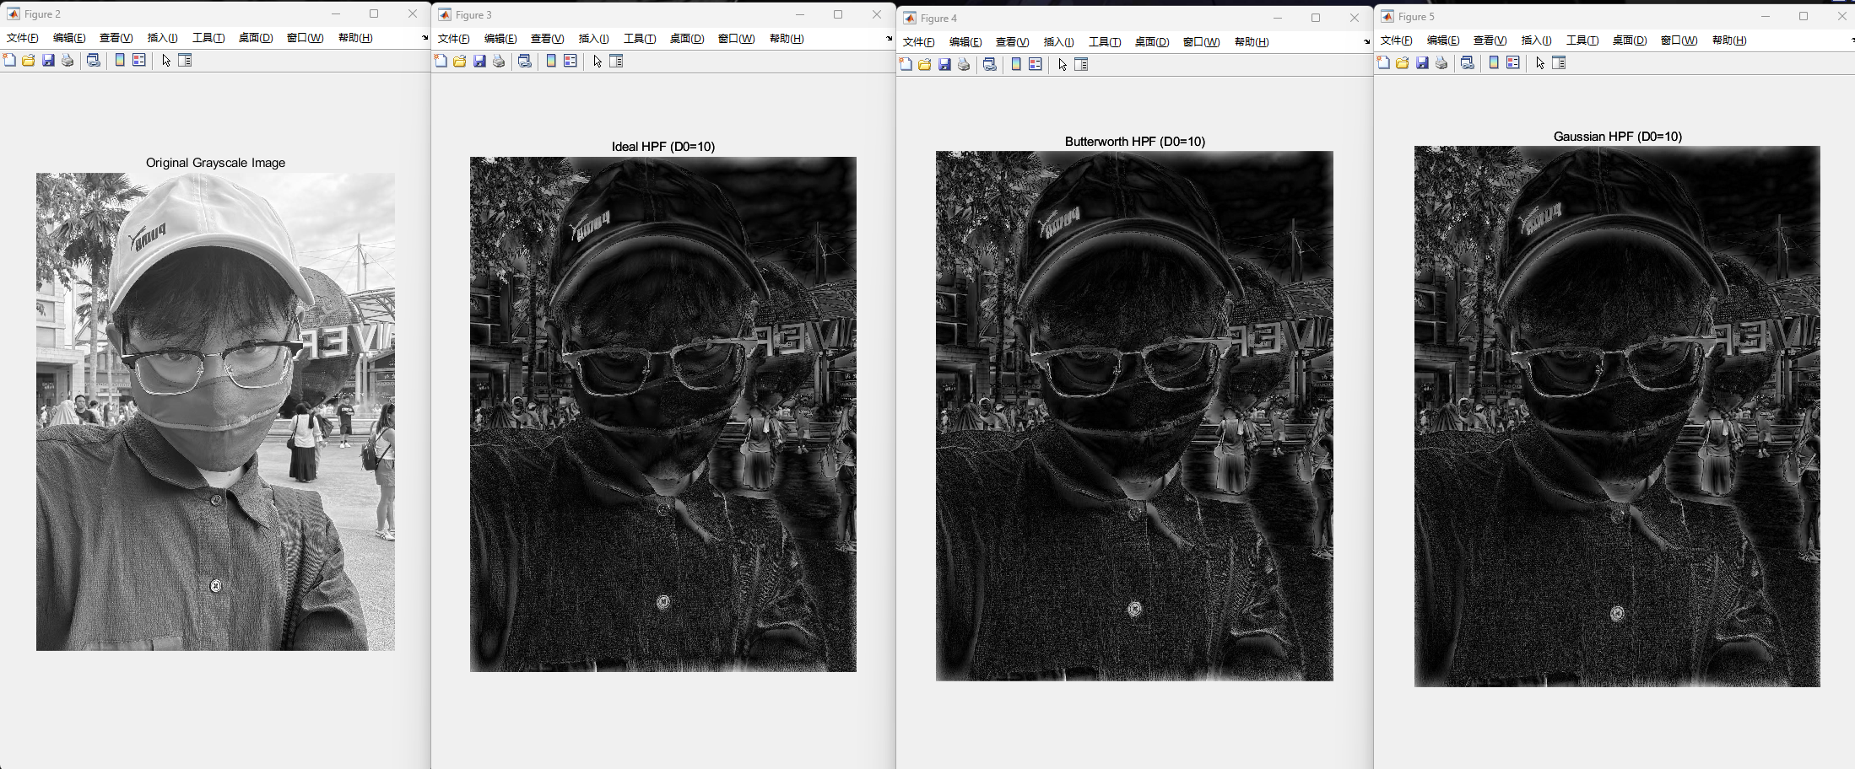

Figure 8: Comparison when cut-off frequency = 10

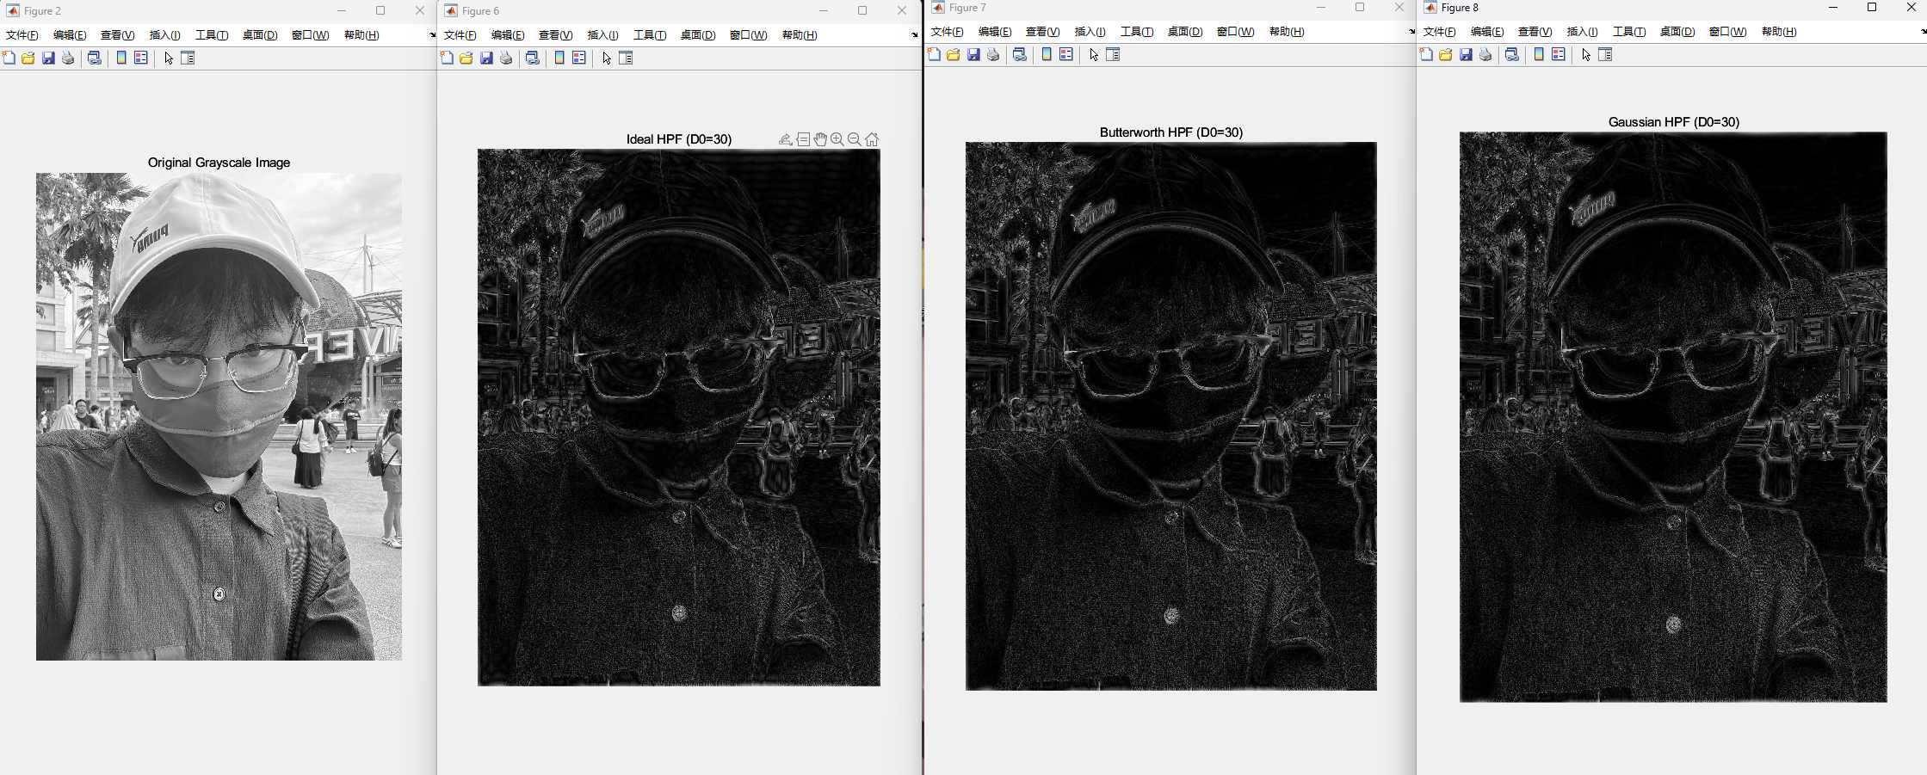

Figure 9: Comparison when cut-off frequency = 10

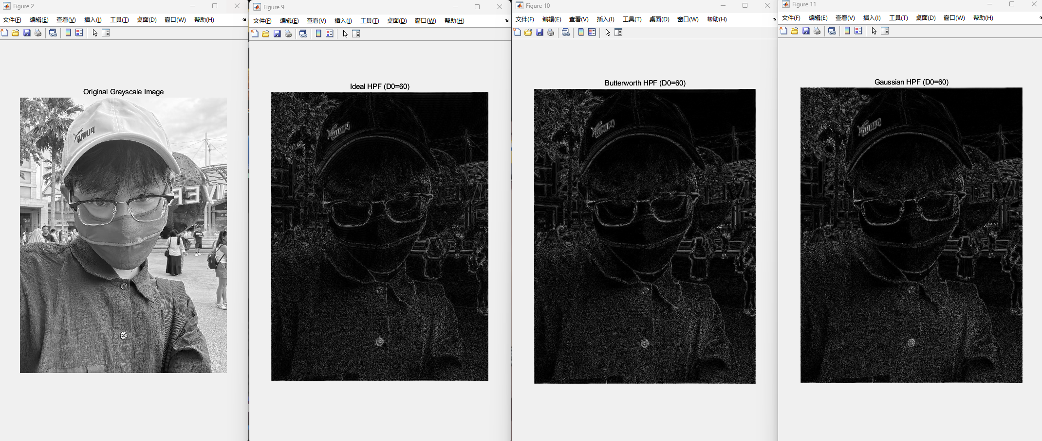

Figure 10: Comparison when cut-off frequency = 10

* **Ideal HPF**: The image shows a sharp cutoff at the specified frequency, enhancing high-frequency details and edges, but may introduce ringing artifacts.
* **Butterworth HPF**: This filter provides a smoother transition compared to the Ideal HPF. The higher the order (n), the sharper the enhancement. It effectively enhances details while minimizing artifacts.
* **Gaussian HPF**: This filter offers the smoothest enhancement of high-frequency details, enhancing edges and textures without significant artifacts.

The following code implements the above functionality:

|  |
| --- |
| % Read the grayscale image  img = imread("C:\License\selfie2.jpg"); % Replace with your image path  gray_img = rgb2gray(img);  figure, imshow(gray_img), title('Original Grayscale Image');  % Perform Fourier Transform  F = fft2(double(gray_img));  F_shifted = fftshift(F);  % Apply High-pass filters with different cut-off frequencies  D0_values = [10, 30, 60]; % Different cut-off frequencies  for D0 = D0_values  H_ideal_high = idealHPF(D0, size(gray_img, 1), size(gray_img, 2));  H_butter_high = butterworthHPF(D0, 2, size(gray_img, 1), size(gray_img, 2)); % n=2  H_gaussian_high = gaussianHPF(D0, size(gray_img, 1), size(gray_img, 2));  % Filter the image  F_ideal_high = H_ideal_high .* F_shifted;  F_butter_high = H_butter_high .* F_shifted;  F_gaussian_high = H_gaussian_high .* F_shifted;  img_ideal_high = ifft2(ifftshift(F_ideal_high));  img_ideal_high = abs(img_ideal_high);  img_butter_high = ifft2(ifftshift(F_butter_high));  img_butter_high = abs(img_butter_high);  img_gaussian_high = ifft2(ifftshift(F_gaussian_high));  img_gaussian_high = abs(img_gaussian_high);  % Display filtered images  figure, imshow(img_ideal_high, []), title(['Ideal HPF (D0=' num2str(D0) ')']);  figure, imshow(img_butter_high, []), title(['Butterworth HPF (D0=' num2str(D0) ')']);  figure, imshow(img_gaussian_high, []), title(['Gaussian HPF (D0=' num2str(D0) ')']);  end  % Define High-pass filter functions  function H = idealHPF(D0, M, N)  H = 1 - idealLPF(D0, M, N);  end  function H = butterworthHPF(D0, n, M, N)  H = 1 - butterworthLPF(D0, n, M, N);  end  function H = gaussianHPF(D0, M, N)  H = 1 - gaussianLPF(D0, M, N);  end  % Define Low-pass filter functions  function H = idealLPF(D0, M, N)  [U, V] = meshgrid(1:N, 1:M);  D = sqrt((U - N/2).^2 + (V - M/2).^2);  H = double(D <= D0);  end  function H = butterworthLPF(D0, n, M, N)  [U, V] = meshgrid(1:N, 1:M);  D = sqrt((U - N/2).^2 + (V - M/2).^2);  H = 1 ./ (1 + (D ./ D0).^(2*n));  end  function H = gaussianLPF(D0, M, N)  [U, V] = meshgrid(1:N, 1:M);  D = sqrt((U - N/2).^2 + (V - M/2).^2);  H = exp(-(D.^2) / (2 * D0^2));  end |

**D. Conclusions**

Through these tasks, we have demonstrated the power and versatility of **Fourier Transform** in image processing. Applying different **low-pass and high-pass filters** showed how frequency domain techniques can be used to modify and enhance image features. Understanding these concepts and their practical applications is crucial for various fields such as computer vision, digital image processing, and signal analysis. The experiments provided valuable insights into the strengths and limitations of different filtering methods, guiding informed choices for specific image processing tasks.